The Secret World of Sharpening

Summary from section 1;
The new space age steels offer us blades that are tough enough for normal usage and will hold an edge very well while standing up to corrosion under normal conditions. Lesser grades of stainless steel will not hold an edge but are used widely in kitchen knives because of the lower cost.
The plainer carbon steels offer us blades that can be sharpened to a very keen edge, can be heat treated to withstand battle conditions, are easy to sharpen, will hold a good edge but requires care to prevent corrosion under normal conditions.
I have made many blades from the high tech steels in the past years and they have performed admirably. Nowadays I prefer to spend much more time with the simpler steels pushing the performance to new high standards through superior heat treating and I also like to make pattern welded blades (Damascus).

Section Two

Sharpening
OK, let’s get started. Edge angle as stated previously is dictated by what you plan to use the knife for. There is no set rule as to what angle you have to sharpen your knife, but a good guide line is sharpen most of your working knives at about 20 degrees on each side of the blade to give you about 40 degrees. 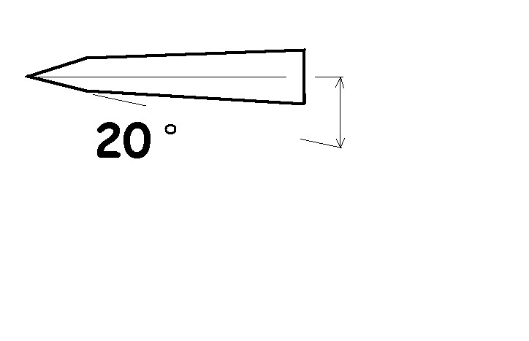This will give you a durable edge for most chores. The straight razors were sharpened at a very thin angle and were made with the sharpening guide built into the design of the blade. In other words the back of the razor was forged thicker on the very spine of the blade so that the blade could be laid down flat on the sharpening stone with both the edge and the spine touching the stone. The spine held the edge at the proper angle to the stone for sharpening. Slick huh?
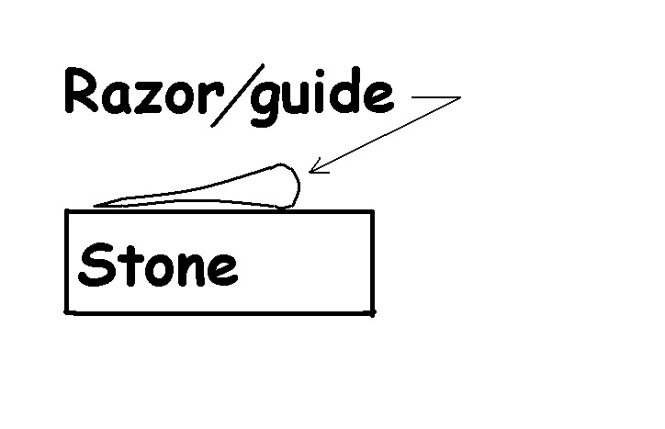
This feature is not incorporated into most knives, as it would create a problem or obstacle with most slicing and cutting chores. A sharpening guide that temporarily clamps on the back of a knife works in the same way and makes a very good sharpening system. There are other systems used in holding the proper edge angle during sharpening and are all very useful. I personally find the Edge-Pro system to be my favorite with the Eze Sharp system close behind. Although it does cost a bit more than most sharpeners, it is easy to use, very accurate and built to last.
The bottom line here is that most of us can train ourselves to hold an approximate angle while stroking a stone but it does take some practice. What is of more value to you, getting proficient at holding an accurate edge angle or getting a great edge with little effort?
Once you have decided on the best edge angle, you should wind up grinding away the metal just behind the projected edge. Do this one both sides and with a fairly course stone until this new facet meets at the very edge. The best way to tell when you have arrived at the edge is when you can no longer see the edge or you can see or feel a burr all along the edge. 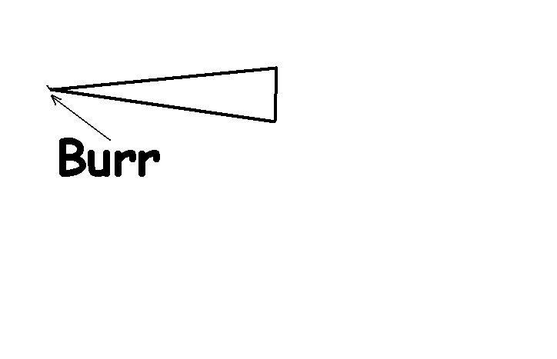
Sharpen evenly from both sides of the knife unless you want it to be a special purpose knife such as a patch knife, sushi knife or a hoof knife. If you do sharpen only one side, use a somewhat steeper edge angle in order to get the same edge angle as with a conventional blade.
The majority of the work will be done with the first stone, so use one that moves steel quickly. Once you have obtained a burr all along the entire edge with say a 180 grit stone, change to a finer 320 grit and using the same angle polish out the course marks left by the first stone. The succeeding finer grits will require very little work and will need very little pressure. If you desire a shaving type edge, change to 600 grit and repeat the process. The wire edge burr will get smaller with succeeding grits and will buff or strop off easily. I should mention that a polished edge will be both sharper and more durable, because you have a real edge instead of a thin wire burr.
Many professionals prefer a double angle edge where the primary grinding is done at a very narrow angle and the very edge is lightly touched with the steeper more durable angle. This configuration coupled with proper blade geometry produces a very good working knife that has reduced drag and an easy to maintain edge between major sharpening.
For the power tool minded, belt grinders and buffers are the way to go. I have sharpened thousands of knives over the past 26 years using this method. You really have to pay strict attention to heat build up, as it is very easy to get the blade hot and ruin the temper. There are many power tools designed for sharpening and the ones that run slow and wet are among the best. The automatic knife sharpeners that you insert the blade and pull through make me shudder, as they remove an excessive amount of steel and never do get the blade sharp.
As mentioned, heat is your enemy here and needs careful watching. If you are grinding up on the flat of the blade, as if in reducing the over all blade thickness, heat build up is not so pronounced, because the heat has several directions to flow and there is mass under the contact area for the heat to flow to. When you are grinding at the edge there is very little mass to absorb the heat energy and only half as many directions for heat flow. Grinding on the tip of the blade has to be done with extreme care as the heat has no where to go.
Belt grinders produce a much better finish than a hard wheel grinder, especially if you use the slack part of the belt. You can get a variety of grits from course to fine. The most popular size for knife makers is the 2” times 72” belts and they come in grits from 36 to 2,000 and no grit for rouge.
The edge grinding performed with a belt grinder is usually done on the slack part between the contact and tracking wheels. I highly recommend that you let the belt run away from the edge, as shown in the illustration, not into the edge. (My grinder is a three wheel rig and I installed a motor reversing switch on it just for this job. I can hold the blade somewhat horizontal with the motor in reverse and watch the burr pop up along the edge as I grind in the bevel. Don’t place the blade edge into the running belt as if to cut into the belt as is sometimes done with the bench stone. If you do, you may actually cut into the belt and bad things will happen at light speed. I have a big scar on my left thumb for testimony.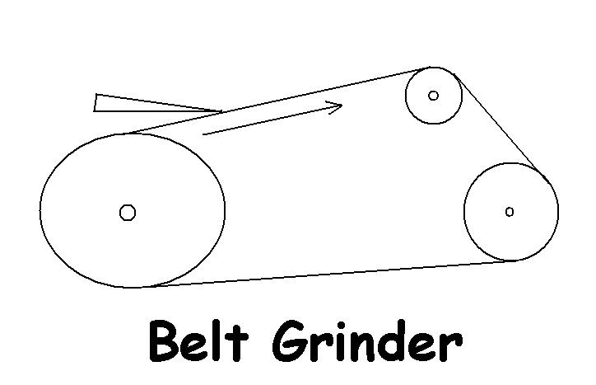If your belt runs vertical as in most two wheel grinders, hold the edge down and let the belt run off of the blade.
Determining the right angle to hold the knife to the belt or stone can be done by actually setting the angle with a protractor, until you get a feel for it. First set the blade edge on something flat and using a protractor or other devise raise the back to 20 degrees or any other angle you want. 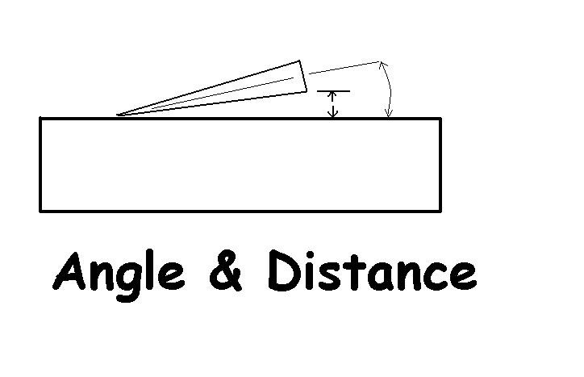 While the blade is at this angle measure the distance of back of blade to the flat surface or just visually remember this distance. To set to the previously sharpened angle, use a strong light and set the blade on something flat and then raise the back of blade until the edge just comes in contact with the flat surface and then measure the back of the blade from the surface. Note that if the blade is dull, you would have to raise it higher than when it was sharp to contact the stone with the edge. Another useful trick that I use at times is to paint the edge with a magic marker. You can tell at a glance just exactly where it is that you are honing on the edge.
Now, when you start grinding the edge, all you have to do is remember the proper distance to keep the back of the blade from the stone or the grinding belt. Take even passes from heal to point, alternating from one side to the other, until you get your burr all the way along the edge. A lot of blades will have a varying thickness along the edge and this will mean more work in some areas, but maintain the same angle throughout. Do not change grits until you have a burr formed from heal to point, then change belts and repeat the process but take very light passes. I usually start with a 180 grit belt unless the knife is really bad and follow up with a 400 grit belt and finish with a worn out belt that has been lubricated and rouged.
The same procedure goes for sharpening by hand. Start with a course enough stone to remove the metal quickly and follow up with the finer stones. Sharpening a dull knife with an Arkansas hard stone is akin to digging a basement with a teaspoon or felling a giant redwood with a pocket knife. But do finish up with it if you have one to obtain a keen edge.
As I have stated before, the Edge-Pro sharpener, in my opinion, is one of the best knife sharpeners ever invented. It normally comes with a 180 grit stone and a 220 grit stone from the manufacturer. This system as it comes would be all you would ever need for your kitchen knives, however I like my knives sharper than that. I have the sharpeners sent to me with a 180 grit stone, a 320 grit stone and also in addition a 600 grit stone for those of us who have to have that ultimate edge. The Edge-Pro gives sharp a whole new perspective.
I liked the Edge-Pro well enough that I have been stocking it for my knife customers and it is a great companion to any one of the knives that I make
Buffing the final edge is widely practiced and does a very quick and efficient job of removing the final burr and bringing up the edge. It needs to be done with care as well so that you do not build up heat and remove the temper. The buffing wheel will conform to the shape of the blade however and will run across the edge of the blade at an angle steeper than what you initially ground it to and ruin your efforts. To prevent the buffer from destroying the edge, reduce the angle just a little that you hold the blade to the buffing wheel but not so low as to let the buffer catch the top of the blade either. Sometimes even I will lose the edge from over buffing and will have to start from scratch. Buffing take a little practice but the results are well worth the time spent learning. Buffing is also the most hazardous work in the knife shop. A blade that is not presented to the buffer properly can be caught by the buffer and thrown with great force. 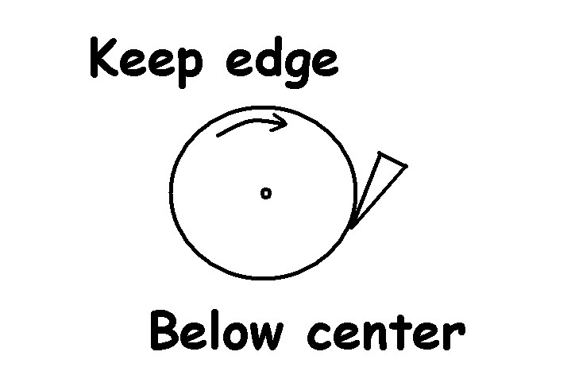
There are some fundamental and important rules to remember when using the buffer. Keep the blade below the center of the buffer shaft. If it is caught it will not be thrown directly at you. Check out the area where you expect the knife to be thrown if caught and decide if you need to place something to catch the blade. Keep the edge down and don’t let the buffer drift up to the top edge of the blade. Keep the point of the blade down also. If your buffer catches the edge or the point of the knife it will get a much better grip on the blade and will destroy the buffer pad to boot. There are some more good rules to remember.
Use a sewn buff, not a loose buff and if you think you just have to buff a double edge blade check your insurance policy first. Last but not necessarily least, slow your buffer down. Do not use a 3600-rpm motor with a large wheel unless reduced down by belt and pulley. The larger the buffing wheels the faster the surface travels at a given rpm, so don’t get carried away with size. Get one large enough to clear obstacles like the motor, pulleys or whatever and run it slow (1750 rpm). If you have a faster motor, use a smaller buffing wheel and extend it with an adapter if necessary to clear the motor.
For a printed copy of the full book, “The Secret World of Sharpening” log on to www.bronksknifeworks.com/sharpening

For the Farrier
The hoof knife has its own challenges.

Because the hoof knife is curved and has a hook on the end of the blade, we have a whole new set of problems to solve. However the fundamentals are still the same. The hoof knife is also sharpened primarily on one side and this requires an adjustment to the angle that it is sharpened to a degree.
I usually sharpen the blades at about 30 degrees and this seems to work for me using my methods. The actual angle at the edge will be steepened up some due to the flex of belts and buffing wheel. The shape of the edge will be curved instead of a flat plane.
One of the methods that I use to sharpen a blade is to use a narrow strip of abrasive 120 grit belt about 30 inches long or more folded and glued back to back so that both sides are abrasive to set up the edge angle. This strip should be about ¾” at the most wide. Fasten one end to something solid about head high and drag the hoof knife down the belt with one hand while holding the belt taught with the other hand. This will do as good a job as any on the hoof knife and is not hard to catch on to. Follow up with a finer grit belt and buffer.
Another method to try is “The Ultimate Edge” diamond sharpening steel. This sharpener is a diamond coated oval tube. It can be used by hand or modified to fit in the Edge Pro sharpening system. I took one of them and cut the handle off to the same length as the stones used in the Edge Pro sharpener and filed the ends at an angle to accept in the guide rod same as the sharpening stones. I then used the last hole in the Hoof knife blade and bolted it down to the Edge Pro with the blade swung forward to obtain the desired angle in the hook part of the blade. The sharpener was set at a low angle to get the oval under the hook and then raised to the proper angle to sharpen the rest of the blade. I also modified some of the finer stones with a bench grinder to fit the shape of the hoof knife for a follow up.
You can use a belt grinder with a narrow belt if it is flexible enough to sharpen the hoof knives. The small 1” by 42” grinders can be gotten fairly inexpensive and you can also mount a small buffer on the shaft where the flat grinding disk is for a compact unit.
The biggest problems with this setup are the belts tendency to grind the curved blade at the edge of the belt requiring some careful work to keep the blade from getting misshapen. It helps to strip the belt in half to help alleviate this problem and it is also better to use a very flexible belt as well.
Always run the belt off of the edge so as not to catch the edge in the belt and watch for the heat build up that will render a good knife worthless by removing the proper knife steel temper i.e. softening the blade. It is a good practice to use belt lube to slow down the heat build up.
Keep the hook of the blade slanting down at the proper angle an let the flexible belt curve into the hook a ways to sharpen that part of the blade.
Once you can see or feel a burr form along the blade, change to a fine belt to remove the scratch mark left by the first grit, then polish with a very flexible rouged fine gritted belt and finally proceed to the buffer.

Buffing takes some care and the buffer can catch the blade and jerk it out of your hand. Always keep the blade lower than the shaft of the buffer so when it does catch, it throws the blade down and away from you. A loose buff will work but a sewn buff will have less loose material to reach over the top of the blade for a hold. Do not use a hard sewn buffing wheel, use one that is spiral sewn and cut the sewing down about ½ to ¾ of an inch. Keep the buffer just flat enough to the wheel so as not to catch the top of the blade and the buffer will flow off of the edge at about the proper angle to remove the final burr and give you a razor edge.

Note; you can sharpen the outside of the hoof knife some but keep the blade flat to the stone or belt and use only the finer grits. This will remove the burr and keep the edge angle on the inside. Also this will give a slight curvature to the outside of the blade and this will help you control the depth of cut.

Perhaps it is becoming obvious now that a good hoof knife should get much sharper and remain sharper longer than one that is to soft, but it does require more that a file to sharpen.

For those who insist that a good knife is impractical, I have this to offer. A sharp knife will require less labor to work, you will get more work done in a day and the sharpening is a small chore once you get the hang of doing it right.

For the gravel impacted feet, I would recommend using a pick and two knives. The pick is used to remove most of the gravel, a starter knife for removing the first layer that can still have some gravel and follow up with a very sharp blade. Always have enough knives at hand to be able to finish with a sharp one. Sharpen at the end of the day.

I try to cover all of the information that you will need to sharpen a knife but it is easy to over look some pertinent information that I just take for granted. So in order to keep you apprised of things that I have discovered that I have forgotten to write or with any new information that I may want to point out in the future, I will try to diligently put it in future newsletters.

I will also put a page on my web site dedicated to answering any questions that I may receive from my friends and customers.

I have an arrangement with Delta Horseshoe Co., I make the Double L Hoof Knives and they are my sole distributor. For direct information on how to purchase a Double L knife, contact Delta at 1 800 931-7181, supplies@deltahorseshoe.com or log on to http://www.deltahorseshoe.com/

